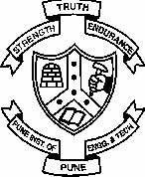College of Engineering, Pune

**(An Autonomous Institute of Government of Maharashtra)**

Applied Science Department

Tel: 020-25507034 Fax: 020-

25507219

**CT16002 – Biology for Engineers**

**UNIT III: Bioenergetics and Metabolism**

**-------------------------------------------------------------------------------------------------------------**

1. **Energy Dynamics in Biology –**
   1. Photosynthesis and energy assimilation: aerobic and anaerobic systems. Applications
   2. Respiration and Electron Transport Chain: Mitochondria and respiration, ATP generation.
2. **Bioenergetics:** Thermodynamic principles applied to biology, negative entropy changes in biological systems, Free Energy, Chemical Equilibrium

-----------------------------------------------------------------------------------------------------------------------

**1) PHOTOSYNTHESIS**

# (PHOTOSYNTHETIC ELECTRON TRANSFER, CALVIN CYCLE)

**Introduction:**

Solar energy is the prime source of energy to entire living world. 2] All living organisms require energy for their life processes. 3] Solar energy can’t be utilized by organisms.

# Important Features of Photosynthesis:

1) It is an intracellular process. 2) It takes place only in green cells of plant 3) During this process organic food is synthesized. 4) It utilizes solar or light energy. 5) It uses CO2 & H2O as raw materials. 6) Solar energy is converted into chemical energy. 7) Only 1 to 5% of solar energy received by earth is utilized in photosynthesis. 8) It is redox reaction where water is oxidized to oxygen & CO2 is reduced to carbohydrates. 9) At first simple sugar like glucose is formed & then complex food like starch, proteins, fats are formed.

10) Chlorophyll acts as a catalyst.

**Definition**:- It is a biochemical process in which organisms prepare complex organic food from simple, inorganic substances like CO2 & H2O with the help of chlorophyll & light energy, releasing O2 as by product.

# Overall reaction: -

**6CO2 + 12H2 O  C 6H12O6 + 6H2O + 6O2**

Photosynthesis is an anabolic (biosynthetic ) & endergonic ( E dependent ) process.

**Pigments and their role** :--1] Photosynthetic pigments of chloroplast in higher plants are chlorophyll & carotenoids.

1. Chlorophyll : - Each chlorophyll molecule looks like a kite or tennis racket with head & tail. Head is made up of 4 pyrol rings with Mg in center. It is hydrophilic Tail is made up of phytol which is long chain alcohol. It is lipophilic, hydrophobic.
2. Chlorophyll a : - It is bluish green, with molecular formula C 55 H 72 O 6 N 4 Mg, absorbs – blue, yellow, red wave lengths of light.
3. Chlorophyll b – It is yellowish green, molecular formula C55H70O6N4Mg ,absorbs – blue, orange wave lengths of light.
4. Carotenoids are carotenes & xanthophylls. Carotenes are yellowish orange with molecular formula C40H56. Xanthophylls are yellow with molecular formula C40H56O2 Carotenoids are long chain hydrocarbons. They don’t have definite shape.
5. All photosynthetic pigments trap light energy in form of photons.
6. Chlorophyll b, Crotenes & Xanthophylls transfer trapped light energy to chlorophyll a by resonance transfer, do not participate actively in photosynthesis. Hence they are called as accessory pigments/antennae pigments/light gatherers. These accessory pigments avoid photo-oxidation of reaction center in intense light.
7. Chlorophyll a collects light energy from these pigments. It also absorbs light energy. It uses light energy for formation of ATP. Hence it is called as active pigment. It acts as a center of chemical reaction. It shows fluorescence.
8. Middle region of quantosomes are called as photocentres or reactive centers.

10) Chlorophyll a has two pigment systems called photosystems i.e. PSI , PSII are involved . PS I absorbs far red light of wavelength 700 nm & PSII absorbs short red light of wavelength 680 nm. Each system has its own type of chlorophyll a i.e. P700 & P680. Both system work in cooperation to capture radiant energy.

PS I – 670 , 683, 700. P – 700 is Reaction center. PSII – 680, 673. P – 680 is Reaction center. PSI – lies on outer surface of thyllacoid, PSII – lies in inner surface of thyllacoid.

Mechanism of Photosynthesis --

Reaction of photosynthesis takes place in two phases i.e. photochemical phase & biochemical phase.

# Primary Process / Photochemical phase / Light reaction

* 1. It takes place in presence of solar energy i.e. light & only in granna of chloroplast. Hence it is light reaction.
  2. Light energy is converted into chemical energy with formation of ATP & NADPH2. Hence it is photochemical phase.
  3. ATP is formed by addition of 1 inorganic phosphate to ADP with the help of energy. This is called as phosphorylation.
  4. Energy required for phosphorylation is obtained from light in form of photons. Hence it is called as photophosphorylation.
  5. During this process e ◌

s are transfered through a system of e ◌

acceptors.

* 1. Two pathways are there of e ◌transfer i.e. cyclic & non cyclic

# (A) Cyclic e ◌transfer / Cyclic photophosphorylation

(1)It involves PS I (Pigment system I). (2) Light strikes chlorophyll-a i.e.P – 700 trap(3) It absorbs quantum of light energy. (4)As a result it is exited i.e. its energy level

increases.(5) Hence it emits a pair of high energy electrons. (6)Energy rich e ◌leave

chlorophyll molecule & hence the chlorophyll molecule becomes +vely charged (ionized)

i.e. unstable.(7)Electrons move through various electron acceptors such as FRS(Z) , ferredoxin, cytochrome b6, cytochrome f & plastocyanin.(8)As energy rich electrons move through electron acceptors, they loose some of their energy which is used for synthesis of ATP from ADP & inorganic phosphate. (9)Finally de-energised electrons return to unstable chlorophyll a molecule which becomes stable. (In one millionth of a second) (10)Thus the electrons lost by chlorophyll molecules return to the same chlorophyll molecule. Hence it is called as cyclic electron transfer.

Cyclic electron transfer occurs when light intensity is low, CO2, O2 low.

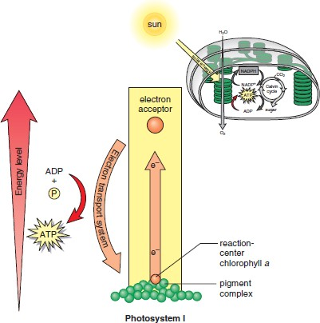

# Non cyclic photophosphorylation / Non cyclic e– transfer

* 1. It involves pigment system I & II i.e. PS I & PS II
  2. Light strikes chlorophyll – a of PS I & PSII i.e. P-- 700 trap & P680 trap.
  3. They absorb quantum of light energy .
  4. As a result they are exited i.e. their energy level increases.
  5. Hence they emit a pair of high energy electrons
  6. Energy rich e–s leave chlorophyll a molecule which becomes + vely charged (Ionised) i.e. unstable.
  7. These e–s from PS II system, which is the primary electron donor, move through various e– acceptors such as FRS, ferredoxin and finally accepted by NADP, that from PS I through plastoquinone, cytochrome b6 , Cytochrome f, plastocyanin.
  8. As energy rich electrons move through electron acceptors, they loose some of their energy which is used for synthesis of ATP from ADP & inorganic phosphate.
  9. In presence of light & chlorophyll a molecule photolysis of water takes place & two electrons , two H + ions & O2 are released. O2 is released outside. These electrons are accepted by chlorophyll –a of PS II & it becomes stable. H ions are accepted by NADP.
  10. Two electrons emitted from PSII are accepted by chlorophyll- a of PS I after it emits two e – s when light strikes on it. Thus chlorophyll-- a of PS I becomes stable.
  11. Finally two H + ions released by photolysis & two e – s released by PSI combine together & reduce NADP to NADPH2
  12. Thus e– s emitted from one pigment system don’t return to it. Hence it is called as non cyclic e– transfer.

FRS – ferredoxin reducing system Ferredoxin – Fe containing flavo protein Cytochromes – Fe containing proteins Platocyanin – Cu “ “

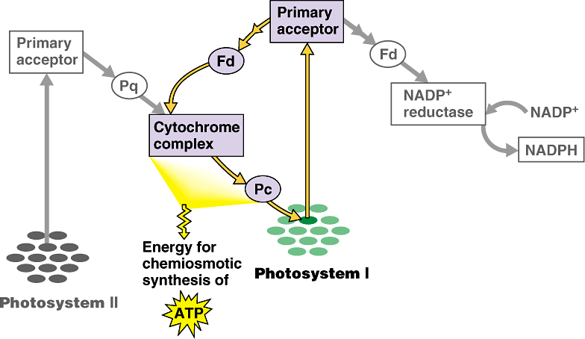

# Significance of Non cyclic e – transfer :-

1] In this pathway ATP & NADPH2 are formed. 2] ATP acts as an energy donar in dark reaction

1. NADPH2 acts as a hydrogen donar in dark reaction
2. Photolysis of water takes place. 5] Oxygen is liberated as bi product.

6] It is more efficient than cyclic photophosphorylation.

|  |  |
| --- | --- |
| **Cyclic Photohosphorylation** | **Non cyclic Photophosphoryltion** |
| 1. e–s return to same chlorophyll molecule from which they are emitted. 2. Photolysis of water doe not take place. 3. O2 is not evolved 4. NDPH2 is not formed 5. NADP doesn’t take part. 6. Only pigment system I is involved 7. Less efficient as less energy is formed. 8. Primary acceptor is FRS (Z) 9. It takes place in photosynthetic bacteria 10. Occurs in low intensity light,   anaerobic condition, less CO2 available | 1. e–s don’t return to same chlorophyll molecule from which they are emitted. 2. Photolysis of water take place. 3. O2 is evolved as bi product. 4. NADPH2 is formed 5. NADP takes part as e - acceptor 6. Both pigment systems I & II are involved. 7. More efficient as more energy is formed. 8. Primary acceptor is FRS (Z) & plastoquinone . 9. It takes place in green plants. 10. Occurs in normal light, aerobic condition, sufficient CO2 |

# Secondary Process / Biochemical Phase / Dark Reaction

* 1. It takes place in stroma of chloroplast, independent of chlorophyll
  2. Light is not required for it. Hence it is known as dark reaction.
  3. ATP, NADPH2 formed during light reaction are used in dark reaction for reducing & fixing CO2 in carbohydrate i.e. hexose sugar. Hence it is also known as CO2

fixation or synthetic phase.

* 1. Energy in ATP is used for various reactions.
  2. Enzymes & coenzymes necessary for dark reaction are present in stroma of chloroplast.
  3. Blackman in 1950 observed this reaction first. Hence it is also called as Blackman’s reaction

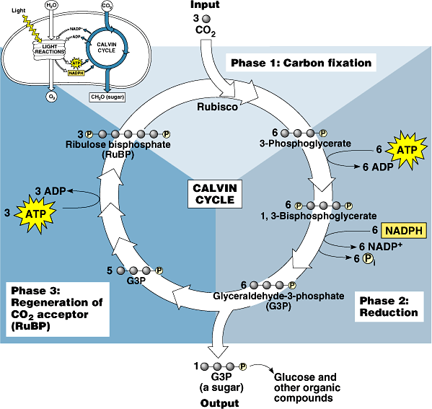

* 1. Melvin Calvin & Benson traced path of carbon during dark reaction. They were awarded Nobel prized in 1961.
  2. During their experiment they fed unicellular algae chlorella & Scenedesmus with radio active carbon isotope i.e. C¹4O2 Algae were allowed to carry photosynthesis. At different time intervals algal cell extract was chemically analysed by paper chromatography to find out compound containing C ¹4. On the basis of products obtained they suggested a cycle for dark reaction which is called as Calvin Cycle.

It has three phases

A] Carboxylation Phase B] Reduction Phase C] Regeneration & Synthetic Phase.

# Carboxylation Phase.

* 1. Atmospheric CO2 is taken by stroma of chloroplast.
  2. RuMP ( Ribulose Mono Phosphate ) – 5 carbon compound is present in stroma. It is phosphroylated into RuDp (RuDP—Ribulose Di Phosphate) It is called as CO2 acceptor
  3. RuDP absorbs atmospheric CO2 & forms unstable 6 C compound.
  4. 6 C compound immediately undergoes hydrolysis & splits into 2 molecules of 3C compound i.e. 3 PGA. This is first stable compound in Calvin Cycle. Hence it is also called as C3 Cycle.

# Reduction Phase –

1. 3PGA is phosphorylated to 1, 3 DPGA( Di Phospho Glyceric Acid )
2. 1, 3 – DPGA is reduced to 3 – PGAL ( Phospho Glyceraldehyde ) by using hydrogen from NADPH2 & in this reaction one inorganic phosphate is released. The process is reverse of oxidation in glycolysis. Hence it is known as glycolytic reversal.

# Regeneration & Synthetic Phase

1. 10 molecules of 3 – PGAL are used for regeneration of RuMP through various phases with formation of 10C, 9C, 8C …… compounds.
2. Two molecules of 3PGAL are used to form hexose sugar i.e. glucose which is converted into starch by polymerization.

Action spectrum – rate of photosynthesis at different wavelengths of light. Absorption spectrum – absorption of light of different wave lengths.

Quantun requirement – no. of photons/quanta required to release 1 molecule of O2

Emerson & Lewis showed that it is 8 quanta.

Red drop – sudden fall in photosynthesis yield beyond red region of spectrum. Showed by Emerson & Lewis.

Emerson’s enhancement effect – if simultaneously shorter & longer wave lengths are provided, rate of photosynthesis is higher than total rate from the beams separately.

RESPITATION

**Introduction** - Living beings need regular supply of energy for vital functions or activities like cell division, transport of materials, locomotion, digestion etc .

**Definition** :– It is an intracellular oxidation -- reduction reaction in which complex organic substances are broken down stepwise to release chemical energy in the form of ATP & CO2 & H2O are given out as byproducts.

**Important features :--** Overall Reaction

# C6H12O6 + 6O2↓ → 6CO2↑ + 6H2O + E (38ATP, 277.44 Kcal)

* In biochemical process the reaction is not so simple.
* Free molecular oxygen does not combine directly with substrate like in combustion.
* Hydrogen is gradually removed from the substrate & the electrons released (H2 → 2H + 2e‾ ) are transferred through a series of e‾ carriers to generate energy in the form of ATP ( exergonic -- energy producing, catabolic – breakdown process )
* The process occurs at cellular temperature.
* Gases are exchanged in liquid medium by blood, tissue fluid etc.
* CO2 & H2O are given out as byproducts.
* All energy in glucose molecule is not converted into ATP but some of it is lost as heat energy.

# ATP –The Energy Currency of the Cell

These are bio-molecules which store energy in biologically usable form.

# ATP – Adenosine Tri Phosphate

It is composed of a) Adenosine – which is made up of adenine [Nitrogen base] +

Ribose Sugar [Pentose sugar] b) 3 phosphate groups

α β γ

# Adenine----- Ribose sugar PO4 ~ PO4 ~ PO4

Second & Third phosphate groups are attached to ribose sugar by high energy bonds, when cell needs energy it breaks the third high energy bond & even the second phosphate bond of ATP forming ADP & AMP respectively

# ATP → ADP + iP + E

All living cells generate ATP by using energy trapped in glucose molecule during photosynthesis. During this process glucose molecule is oxidized. In this reaction CO2 & H2O are given out as by products. This is called as cellular respiration. Energy released is trapped in ATP molecule by attaching phosphate group. This is called as phosphorylation. As glucose molecule is oxidized it is called as oxidative phosphorylation.

**Significance** : 1] It stores energy in biological usable form. 2] It supplies energy in

various cellular activities by breaking phosphate bond in between 2nd & 3rd and

even 1st & 2nd phosphate groups. 3] It acts as a phosphate donar in various biochemical reactions.

* + Cellular respiration is oxidation of food material into CO2 and H2O.
  + During this oxidation E released is trapped in ATP ( 1ATP traps 7.28 k cal)for using in all cell activities.

This oxidation occurs in three phases.

1. **Glycolysis** – Breakdown of glucose to pyruvic acid (pyruvate). It occurs in cytosol i.e. cytoplasm. Hence mitochondria are not necessary. In occurs in prokaryotes as well as eukaryotes. As O2 is also not required it is common to aerobic as well as anaerobic organisms. In glycolysis 2 ATP and 2 NADH + H+ also formed.

# Citric Acid Cycle / Krebs cycle -

* + Decarboxylation of pyruvic acid to CO2 and H2O along with formation of NADH + H+ and FADH2.
  + In eukaryotes it occurs in mitochondrial matrix. Matrix has complex mixture of soluble enzymes for decarboxylation of pyruvic acid.

At the end 3CO2 , 4 NADH + H+, 1 FADH2 are formed (when 2e – are removed from malic acid transferred to NAD+ reducing it to NADH + H+, same way 2 e – removed from saccinic acid and reduces FAD. To FADH2

Outer membrane – contains many complexes of integral membrane proteins that form channels – porins through which many molecules and ions move in and out of mitochondria.

* + e – from NADH and FADH2 are transferred to next phase i.e. respiratory chain.

# Electron Transport Chain / Respiratory Chain -

* + Inner membrane of mitochondria contains complexes of integral membrane proteins.

NADH dehydrogenase complex Succinate dehydrogenase complex Cytochrome c reductase complex Cytochrome c oxidase cpmplex ATP synthase complex

* + It also consists ubiquinone, cytochrome a,b,c, which shuttle electrons from one complex to another.

Inner membrane is selectively permeable.

(NADH carries e – from catabolic reactions to respiratory chain. NADPH supplies e – to anabolic reactions.)

* + Stepwise transfer of e – from NADH, Ubiquinone, Cytochromes and then finally to O2 to form H2O takes place. Neither NADH nor NADPH can cross inner mitochondrial membrane, but the e – carried by them can shuttle across.
  + During e – transfer E is released.
  + It is used to transfer/ pump H+ (protons) from matrix into inter membrane space by active transport.
  + Thus matrix becomes – vely charged and inter membrane space +vely charged.
  + Gradient of protons formed across the inner membrane forms a miniature battery. (Mitochondria contain 3 classes of cytochromes – a,b,c which absorb different light spectra)

[Plastoquinone is like ubiquinone. Ubiquinone ( Coenzyme Q)  small, hydrophobic, hence freely diffusible in lipid bilayer of inner mitochondrial membrane and can shuttle reducing equivalents between other less mobile electron carriers in the membrane. Cytochromes  proteins with iron – heme group; show strong absorption of visible light.)

* + In mitochondrial respiratory chain, e – move as follows – NADH / FADH2  Co.Q  Cytochrome b  Cytochrome C1  Cytochrome C  Cytochrome a  Cytochrome a3  O2.

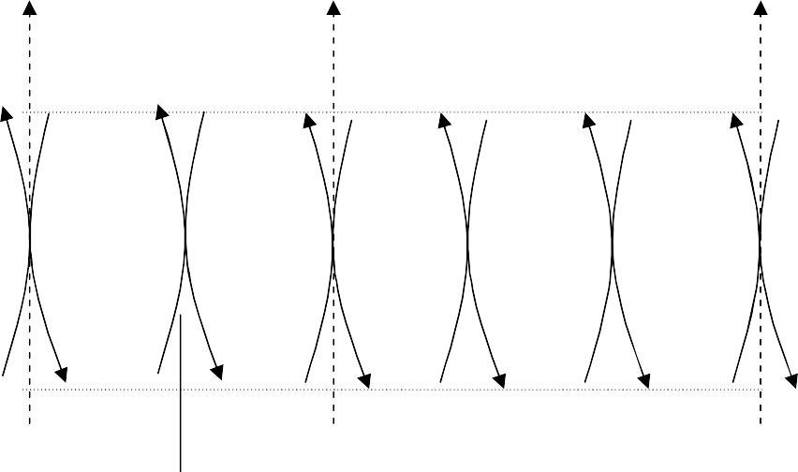

AH2 FAD

FADH2

ATP ATP ATP

CoQ

A

NAD

NAD

2

Fe+++

Fe+++ Fe+++ Fe+++ Fe+++ 1/2 O2

Cyt b Cyto C1 Cyt C Cyt a Cyt a3

H CoQH2

AH

Fe++

Fe++ Fe++ Fe++ Fe++ H2O

2H+

ADP + iP ADP + iP ADP+ iP

# Chemiosmosis in Mitochondria:-

* + As e – pass from NADH + H+ / FADH2 down the gradient to O2, E is released.
  + This E is used to pump H+ (protons)from matrix into inter membrane space against conc. / electrochemical gradient by active transport
  + As proton conc. increases in inter membrane space; a strong diffusion gradient is set up.
  + These protons can only exit through ATP synthase complex into matrix .
  + E is released as protons flow down their conc. gradient through specific protein channels in inner membrane. This free E is utilized for ATP synthesis. The process catalyzed by a membrane protein complex ATP synthase. ATP synthase is present in elementary particles of inner membrane. Mitochondrial ATP synthase is an F-type ATP ase . ATP synthase has two distinct components : F1 → peripheral membrane protein & Fo → integral to above membrane. Fo has a proton pore through which protons leak as fast as they are pumped by e‾ transport. Without a proton gradient the F1 depleted vesicles can’t make ATP. On the other hand isolated F1 catalyze ATP hydrolysis ( reversal of synthesis) hence originally called as F1 ATP ase. When purified F1is added back to depleted vesicles, it reassociates with Fo plugging its proton pore & restoring membrane’s capacity to couple e‾ transfer & ATP synthesis.
  + This transfer of protons along concentration gradient from inter membrane space to matrix is called chemiosmosis. It is an example of facilitated diffusion.

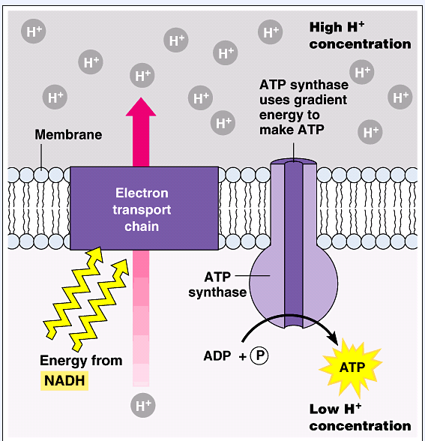

* + Peter Mitchell proposed chemiosmotic model. According to this model transmembrane differences in proton concentration are the reservoir for E extracted biological oxidation reactions.
  + Inhibitors of e – transfer to O2, like cyanide, CO, antimycin A, block ATP synthesis and vice versa. (oligomycin inhibits ATP synthase activity. ) Thus these two processes show obligatory coupling.

# Mitochondrial DNA:-

* + Human mitochondrion contains 5 – 10 circular DNA molecules – mt – DNA.
  + Mutation in mt – DNA causes human diseases; affecting mainly brain and muscles.
  + In mammals 99.99% of mt DNA is inherited from mother. This is because in zygote paternal mitochondria are only about 100, while maternal are 100,000.

**2) BIOENERGETICS**

Living cells and organisms must perform work to stay alive and to reproduce themselves. The synthetic reactions that occur within cells, like synthetic processes in any factory, require the input of energy. Energy is also consumed in the motion of a bacterium or an Olympic sprinter.

Although the characteristic composition of an organism changes little through time, the population of molecules within the organism is far from static. Small molecules, macromolecules, and supra-molecular complexes are continuously synthesized and then broken down in chemical reactions that involve a constant flux of mass and energy through the system. The hemoglobin molecules carrying oxygen from your lungs to your brain at this moment were synthesized within the past month; by next month they will have been degraded and entirely replaced by new hemoglobin molecules. The amounts of hemoglobin in the blood remain nearly constant because the rate of synthesis balances the rate of its breakdown, the constancy of concentration is the result of a dynamic steady state, a steady state that is far from equilibrium. Maintaining this steady state requires the constant investment of energy; when the cell can no longer generate energy, it dies and begins to decay toward equilibrium with its surroundings.

**Metabolism** –The sum of all chemical transformations taking place in a cell

/organism.

**Metabolic pathways** – A series of enzyme catalyzed reactions. Each step in it brings about specific, small chemical change like removal, transfer / addition of a particular atom / functional group.

**Metabolites** – Metabolic intermediates which convert precursors into products.

**Intermediary metabolism** – Combined activities of all metabolic pathways that interconvert precursors, metabolites & products of low molecular weight

**Catabolism** --The degradative phase of metabolism in which organic nutrient molecules (carbohydrates, fats, and proteins) are converted into smaller, simpler end products (such as lactic acid, CO2, NH3). Catabolic pathways release energy, some of which is conserved in the formation of ATP and reduced electron carriers (NADH, NADPH, and FADH2); the rest is lost as heat.

**Anabolism** –(also called biosynthesis ) Small, simple precursors are built up into larger and more complex molecules, including lipids, polysaccharides, proteins, and nucleic acids. Anabolic reactions require an input of energy.

**Bioenergetics** - The quantitative study of the energy transductions that occur in living cells and study of the nature and function of the chemical processes underlying these transductions. Biological energy is not in the form of heat mechanical or light energy therefore word thermodynamics is not used but word bioenergetics is used. This energy is termed as free energy and defined as energy available for work. It symbolizes change in energy and not the absolute energy.

Two approaches to study physical or chemical processes:

**Kinetic molecular approach**: In this, process is studied in terms of molecules and atoms.

**Thermodynamic approach**: Process id studied by considering energy changes involved. Thermodynamics means study of heat flow. But actually not only relation between heat and work but also deals with all kinds of inter conversion of one kind of energy in to the other. Most of the energy forms are ultimately converted in to heat.

Thermodynamics help to forecast whether certain physical or chemical transformations are possible or not. Under given set of conditions of temperature, pressure, concentration etc. But it can not give any information of time required for completion of change as well as rate of reaction.

If the system exchanges neither matter nor energy with its surroundings, it is said to be **isolated**. If the system exchanges energy but not matter with its surroundings, it is a **closed system**; if it exchanges both energy and matter with its surroundings, it is an **open system.**

A living organism is an open system; it exchanges both matter and energy with its surroundings. Living organisms derive energy from their surroundings in two ways:

1. They take up chemical fuels (such as glucose) from the environment and extract energy by oxidizing them; or
2. They absorb energy from sunlight.

**Homogenous system** – System with same chemical composition throughout.

**Heterogenous system** – System with two or more phases which are homogenous themselves but separated from each other by definite boundary. (ice and water)

**State of a system:** Variable of a state are temperature, pressure, volume, composition

# Gas Equation: PV = nRT

Therefore if 2 values are known the third can be determined thus state of a simple homogenous system can be defined. Physical properties of a system are of two types:

**Extensive properties:** Depend on quantity of matter in the system under consideration e.g. mass, volume, energy

**Intensive properties:** Depend on nature of substance and independent of its amount e.g. temperature, pressure, viscocity, refractive index

**Thermodynamic equilibrium**: It is said to achieved when observable properties like temperature, pressure, volume does not change with time. For thermodynamic studies a system must be in in 3 types of equilibria which must exist simultaneously.

# Thermal equilibrium

1. **Chemical equilibrium**
2. **Mechanical equilibrium:** No movement of particles of the constituents of system itself and between itself and surroundings.

**Isothermal process**: Temperature remains same

For Exothermal process – heat evolved give out immediately to surroundings to maintain the temperature. For endothermic process required amount of heat enters the system from surroundings to maintain the temperature.

**Adiabatic process** – heat neither enters nor leaves the system during the process.

# Thermodynamic laws and living organisms

The molecular complexity and orderliness of structure of living organisms is much higher in contrast to the randomness of non living matter.

# The first law of thermodynamics, fully valid for biological systems

Photosynthetic cells absorb light energy and use it to drive electrons from water to carbon dioxide, forming energy-rich products such as glucose (C6H12O6), starch, and sucrose and releasing O2 into the atmosphere:

Light 6 CO2 + 6 H2O  C6H12O6 + 6 O2

(light-driven reduction of CO2)

Non – photosynthetic cells and organisms obtain the energy they need by oxidizing the energy-rich products of photosynthesis and then passing electrons to atmospheric O2 to form water, carbon dioxide, and other end products, which are recycled in the environment:

C6H12O6 + O2  6 CO2 + 6 H2O + energy (energy-yielding oxidation of glucose)

DNA, RNA, and proteins are informational macromolecules. In addition to using chemical energy to form the covalent bonds between the subunits in these polymers, the cell must invest energy to order the subunits in their correct sequence. It is extremely improbable that amino acids in a mixture would spontaneously condense into a single type of protein, with a unique sequence. This would represent increased order in a population of molecules; but according to the second law of thermodynamics, the tendency in nature is toward ever- greater disorder in the universe: the total entropy of the universe is continually increasing. To bring about the synthesis of macromolecules from their monomeric units, free energy must be supplied to the system (in this case, the cell).

# Second law of thermodynamics

How living organisms can create and maintain their intricate orderliness in an environment that is relatively disordered and becoming more with the time ? Living organisms do not constitute exceptions to thermodynamic laws. Their high degree of molecular orderliness must be paid for in some way since it can not arise spontaneously from disorder.

Living organisms have following characteristic properties such as,

* 1. **Use free energy**: Living organisms absorb useful form of energy that is free energy from surrounding under specific temperature and pressure and return less useful form of energy to the environment in equal amount. The useful form of energy returned by the living organisms is heat or other form that is quickly randomized in the environment and thus increase the entropy.
  2. **Open system**: living organisms are not in equilibrium with the environment
  3. **Steady state**: Cell is non equilibrium open system, a machine for extracting free energy from the environment which it causes to increase in randomness. The

rate of transfer of energy and matter from environment in to system is equal to transfer of energy and matter from system to environment.

* 1. **Non equilibrium**: Open system in steady state can do work in non equilibrium. Process under non equilibrium can be regulated. This is orderly state of an open system.
  2. **Isothermal system**: The living system is essentially isothermal that is at any given time all parts of the cell have the same temperature. Furthermore, there are no significant differences in pressure between one part of the cell and another. For this reason, cells are unable to use heat as a source of energy, since, heat can do work at constant pressure only if it passes from a higher to a lower temperature zone.
  3. **Isothermal chemical engines**: energy absorbed from environment id transformed to carry out synthesis of cell components, osmotic work, transport of material into cell, nerve conduction, muscle contraction etc. which takes place at constant struggle against the tendency to produce entropy. Synthesis of large and information rich macromolecules, the information of intricately structured cells, development of an organization, all these are powerful anti entropic doom imposed on all natural phenomenons. Under the second law of thermodynamics, living organisms choose the least evil – they produce entropy at a minimum rate by maintaining steady state.

An attempt to produce a machine which could produce more mechanical work than the equivalent energy used is failed. This compels to accept the first law of thermodynamics in biological systems.

# Mathematical formulation of first law

Suppose some amount of heat is put in the system, Since heat can not be lost it must remain either partial or whole in the system, or can used up by the system in doing mechanical work.

In general case, when both happen,

# Heat absorbed = increase of internal energy + work done by the system

If final and initial internal energy of the system is E2 and E1 respectively, then increase internal energy is **∆E = E2- E1**

If heat absorbed is **q** and work done is **w** then

**∆E = E2 – E1 = q – w** (this is first law of thermodynamics)

Although the heat absorbed / the work done by the system might vary the path by which the change is affected ∆E is always same.

# Second law of thermodynamics:

1. First law explains the equivalence between heat and work but imposes no condition on their mutual convertibility. It never explains under what circumstances and to what extent it is possible to convert one form of energy in to other.
2. It also explains about the amount of heat lost by a hot body must be equivalent to the gain by cold body. But is does not explains that heat has to flow spontaneously from hot to cold body and not in reverse direction.
3. Different forms of energy can be readily and completely converted in to heat but not possible to convert back heat completely in to work. Hence, there must be some other law besides the first law that governs the direction of flow of heat and extent of its convertibility in to work. This limitation forms the basis for second law of thermodynamics. **The total entropy of a system must increase if the process has to occur spontaneously**.

**Entropy**: The quantitative expression for randomness or disorder of the components of a chemical system is expressed as entropy, S.

When the products of a reaction are less complex & more disordered than the reactants, the reaction proceeds with a gain in entropy. Any change in randomness of the system is expressed as **entropy change, S**, which by convention has a positive value when randomness increases. **J. Willard Gibbs**, who developed the theory of energy changes during chemical reactions, showed that the **free energy content, G,** of any closed system can be defined in terms of three quantities:

**Enthalpy, H** – heat content of reacting system, reflecting the number and kinds of chemical bonds in the reactants & products; **Entropy, S**; and the **absolute temperature, T** (in degrees Kelvin).

# The definition of free energy is G = H – TS.

When a chemical reaction occurs in biological system at constant temperature & pressure, the free-energy change, G, is determined by the enthalpy change, H, reflecting the kinds and numbers of chemical bonds and non covalent interactions broken and formed, and the entropy change, S, describing the change in the system’s randomness:

G / ∆F = H – T S (F → Heltmoz free E, T→ absolute temp.) Also ∆G / ∆F = ∆E – T ∆S ( E/Q → internal energy)

Hence total energy of the system is ∆E = ∆G + T ∆S

If **∆G is negative**, the reaction would proceed spontaneously with loss of free energy that is exergonic reaction. If in addition, ∆G is of great magnitude, the reaction goes virtually to completion and is essentially irreversible.

If **∆G is positive**, the reaction can not occur spontaneously and would proceed only if the free energy can be gained that is endergonic.

If **∆G is zero**, the system is at equilibrium and no net change takes place.

Relationship between equilibrium constant and standard free energy change in a model reaction. Thus, in a reaction, **A + B ↔ C + D**

[C] [D]

∆G = ∆G0+ RT ln ---------------------

[A] [B]

When the concentration of [A] [B] [C] [D] ∆G is 0.1 M, ∆G0 known as standard free energy change. At equilibrium, ∆G0 = 0

# [C] [D]

**i.e. ∆G = ∆G0+ RT ln ---------------------**

**[A] [B]**

For biochemical reactions, a standard state is defined as having a pH of 7. the standard free energy change at this standard state is denoted by ∆G0 since the equilibrium constant under standard condition is;

K’eq = [C] [D] / [A] [B]

Substitution gives ∆G0 = - RT ln K’ eq

Thus, the standard free energy change can be calculated from the equilibrium constant K’ eq it is important to note that ∆G may be larger or smaller than ∆G0’ depending on the concentration of various reactants.